Real Estate. Is the Recovery for Real?
Every time I turn on the TV or listen to the radio I hear people telling me that real estate is booming again. The headlines shown below, from Forbes.com and RealEstate.com, are typical of what is being pumped out there on a daily basis. The question becomes whether to believe your own experience or the media announcers.
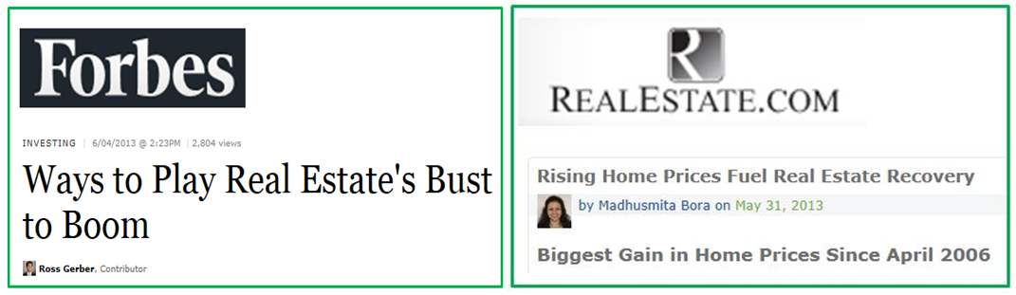

I know many people who have been unsuccessfully been trying to sell their homes for more than one year. They have cut their asking prices, switched realtors and run multiple open houses without receiving anything but insulting, low-ball offers. Certainly, this is anecdotal evidence and not statistically significant all by iteslf. The June 5, 2013 Chart of the Day (see below) was an eye-opener. We all know that housing prices percolated to bubble valuations in the 2004 – 2005 time frame. It is common knowledge that the bubble popped in 2006 – 2007. Most people think that home prices troughed in 2009 along with the stock market. That is totally incorrect. In most areas of the country things kept getting worse until 2010 - 2011.
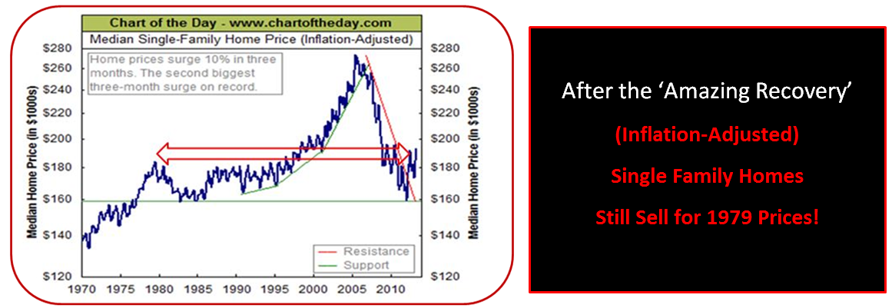

On-line realty site Zillow (Z: $52.88) confirms this as well. Things are much less ebullient that we are hearing on a daily basis. Note: Zillow’s price charts use raw dollar prices rather than inflation adjusted figures. Nevada and Florida were two of the most inflated, then hardest hit areas during the full housing cycle. They each show only modest rebounds after suffering devastating percentage declines. My own zip-code, in a suburb of Philadelphia, showed the same pattern as Las Vegas and Hallandale, Florida but with somewhat less dramatic swings. Most geographical areas now sell for nominal prices pretty close to where they were about ten years ago, in 2003.
Whoever coined the term ‘Zestimates’ should get a medal. I hope they copywrited that brilliant name and made a ton of money from it. It belongs right up their with ‘smog’ and ‘staycation’ in the newly-created-word hall of fame.
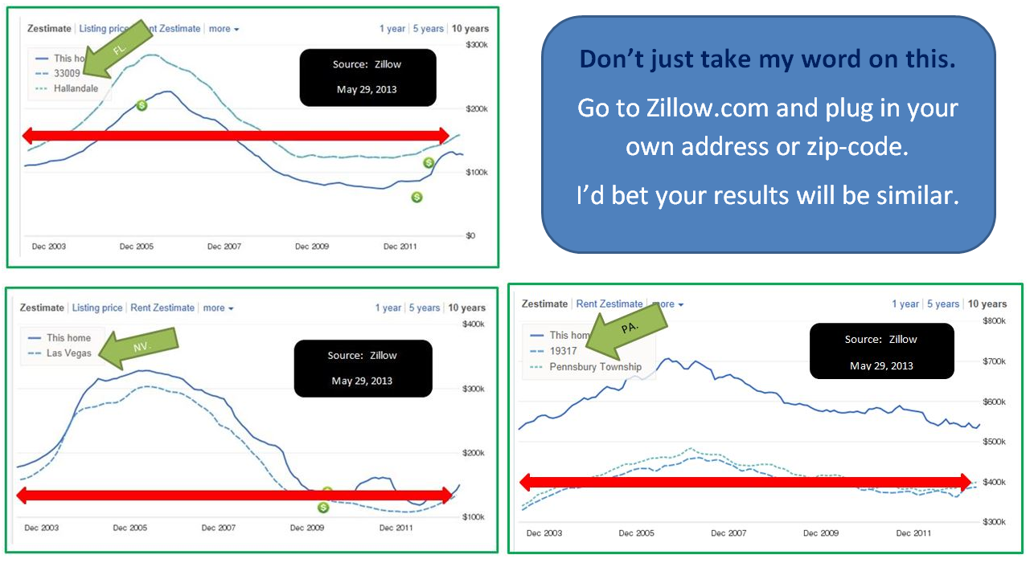
Re-Max, Prudential, Century-21 and other real estate brokers want you to get back in the market. Washington, D.C. hopes you’ll get with the program and start spending more freely due to the ‘wealth effect’ of a higher perceived home value.
Until my friends start getting reasonable offers put me firmly in the skeptical camp when it comes to believing the media hype .

